**Second Year Computing**

**Web Development and Practical Databases**

**CSS Exercises**

**Lab Sheet 1**

Using an Internal style sheet complete Exercises 1 to Exercise 3

**Exercise 1**

Define your own styles for the h1, h2, …, h6 tags, and create a document with six heading levels that use the newly defined header styles.

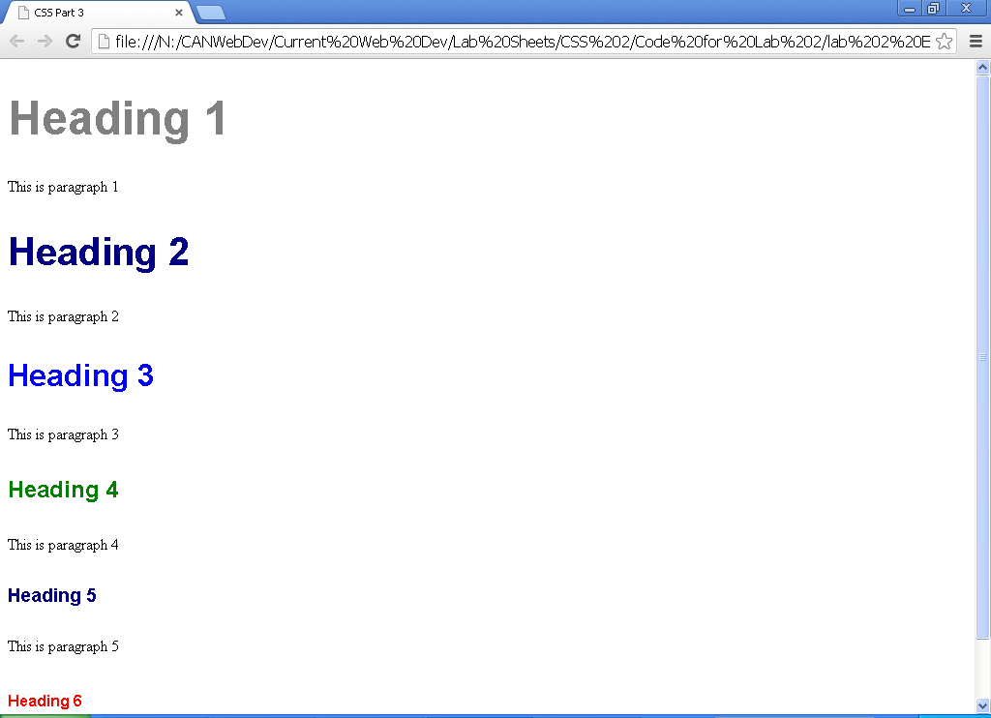

*Save your exercise files on M/WebDev/CSS Exercises/lab 1/ E1.html*

**Exercise 2**

Define three different paragraph class styles, p1, p2, and p3 that meet the following requirements:

* p1:
  + left and right margins of 20 pixels
  + background colour of Pink
  + foreground colour of blue.
  + font-family of Arial,Helvetica,sans-serif
  + font-size 10pt
  + font-weight normal
  + left aligned text
* p2:
  + left and right margins of 30 pixels
  + background colour of black
  + foreground colour of Grey
  + font-family of Arial,Helvetica,sans-serif
  + font-size 10pt
  + font-weight normal
* p3:
  + text indent of 1 centimeter
  + background color of aqua
  + foreground color of white
  + font-family of Arial,Helvetica,sans-serif
  + font-size 10pt
  + font-weight normal

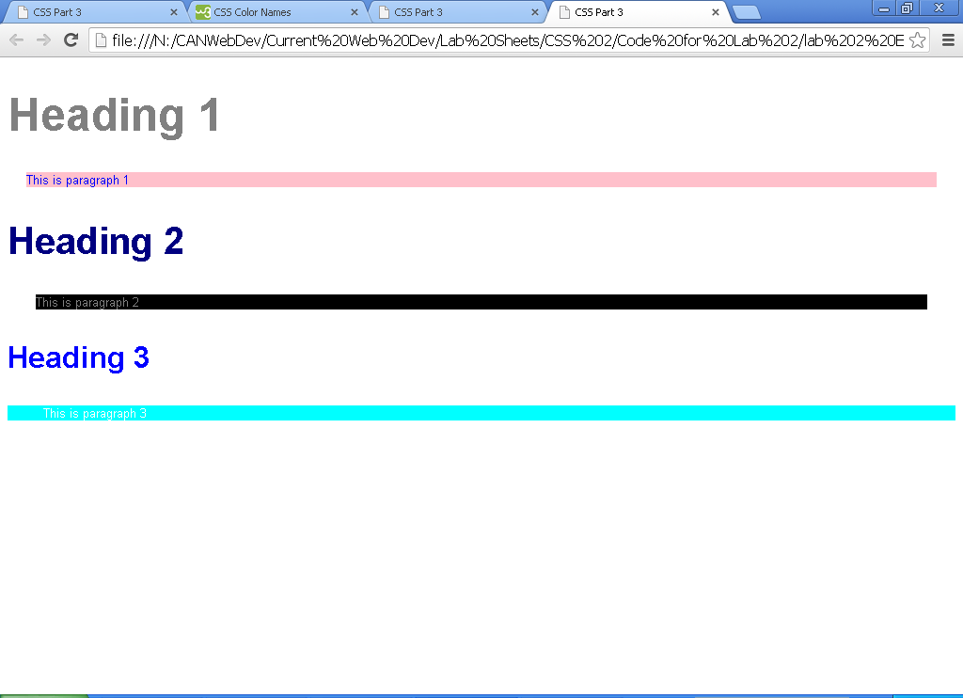

*Save your exercise files on M/WebDev/CSS Exercises/lab 1/ E2.html*

**Exercise 3**

Create six paragraphs, each with a heading.  Use h1 through h6 for the headings.  Then create a paragraph under each heading. The first and fourth paragraph must use p1, the second and fifth must use p2, and the third and sixth must use p3.

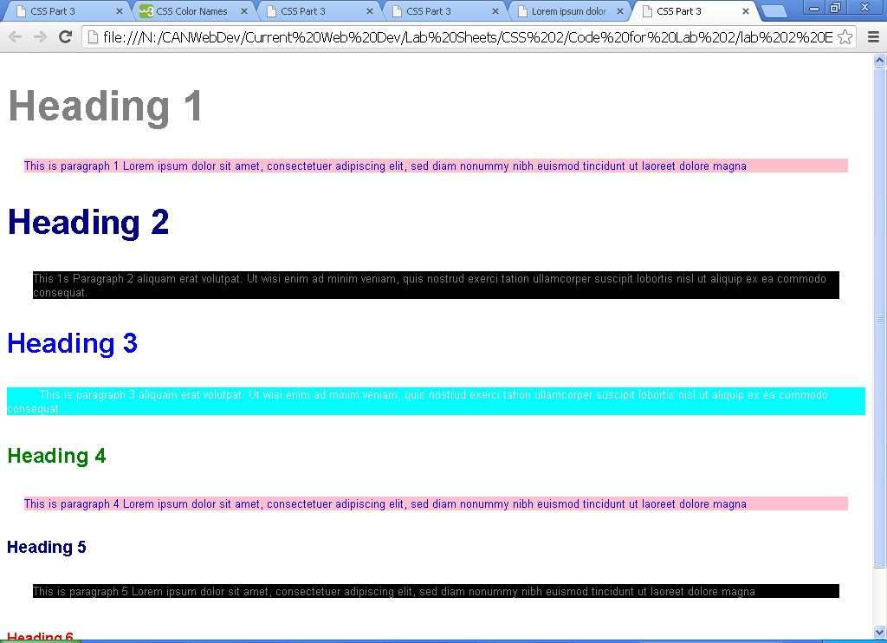

*Save your exercise files on M/WebDev/CSS Exercises/lab 1/ E3.html*

**Exercise 4**

Move the internal style sheet to an external style sheet file, and link the external style sheet file to your document.

You should see the same result as the previous exercise.

*Save your exercise files on M/WebDev/CSS Exercises/lab 1/ E4.html, and E4.css*

Define additional styles in the external style sheet for the following two exercises.

**Exercise 5**

Create at least two divs that each include an image and enough text to precede the images, flow around them (one on the left and one on the right), and continue after the image.

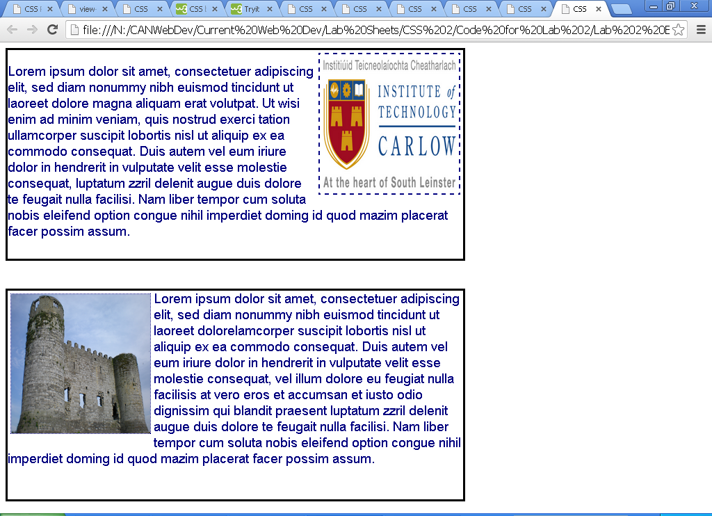

*Save your exercise files on M/WebDev/CSS Exercises/lab 1/ E5.html, and E5.css*

**Exercise 6**

Create an unordered list of three popular books. The bullet for each book must be a small image of the book's cover. Find the images on the Web.

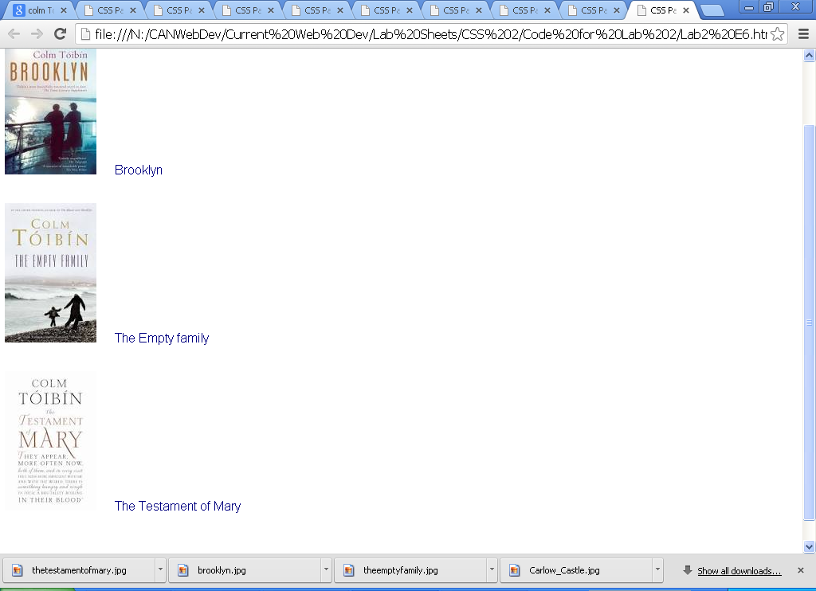

*Save your exercise files on M/WebDev/CSS Exercises/lab 1/ E6.html, and E6.css*